|  |
| --- |
| **JDN Standards – Meso Documentation** |

Introduction 1

Guidelines 1

Switch Config 1

Firewall Config 1

Configure VRTX or R430 1

Configuring the DC 2

Further deployment 3

Issue handling 3

# Introduction

This document provides guide lines on how to install a JDN Integrated Site.

# Guidelines

## Switch Config

<http://meso.jandenul.com/meso-webtop/drl/objectId/090236ed83647584>

## Firewall Config

<http://meso.jandenul.com/meso-webtop/drl/objectId/090236ed8378d956>

## Configure VRTX or R430

Follow the required guide for your device until you have deployed the DC:

DO NOT CONFIGURE THE DC

* VRTX: <http://meso.jandenul.com/meso-webtop/drl/objectId/090236ed83bc7522>
* R430: <http://meso.jandenul.com/meso-webtop/drl/objectId/090236ed83ca8bf7>

## Configuring the DC

Once the DC has been deployed we need to make it accessible to SA/SE.

For this we need to open RDP and have a VPN connection (Create ticket if you don’t have VPN yet).

Open a connection to your DC and execute following steps:

<http://meso.jandenul.com/meso-webtop/drl/objectId/0b0236ed82fe4f68>

1. Execute the PS-script ‘*Set-NetworkSettingsJDN.ps1*’ , this will ask you to provide a value for ‘IP’. This has to be x.x.x.11 (x.x.x is your admintrust range).

This script will set the IP-address, DNS forwarders and allow RDP.

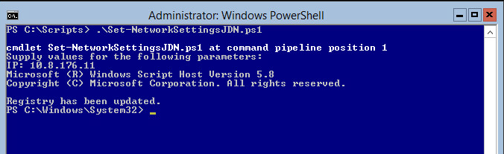

1. Create a request @ SA/SE to join the DC to the JDN domain. Ask for admin permissions on your DC (adl).

**Promoting DC's in the jandenul.com domain can only be done on request (e.g. slow internet connection on site)**

1. Once Fulfilled continue by running the DHCP config and Create AD-Site scripts on your DC

DO NOT EXECUTE THE DNS SCRIPTS THESE WILL OVERWRITE THE JDN GENERAL DNS.

1. Join the server VM’s into JDN domain.
2. Create a request @ SA/SE to authorize your DHCP server in the JDN domain and move the server VM’s to the correct OU’s

## Further deployment

When done with the DC continue the general deployment as explained in the Configure VRTX or R430 guides.

Note: Check special IAP config at the bottom of <http://meso.jandenul.com/meso-webtop/drl/objectId/090236ed83ccc634>

Don’t forget to log a request for the Radius.

## Issue handling

Since this is a JDN site you will not have all the Admin rights to solve some issues.

Problems with DC -> contact Ben Nuyens

Problems with Scripts -> Bruno Buyck

Problems with rights on VM’s (JDN devices) -> Michael De Witte